Agro Savore – User Test Observation
Correction 1 Header color change use BG Hex #c7ff20 across all page, Change the button colors to
#7fb439
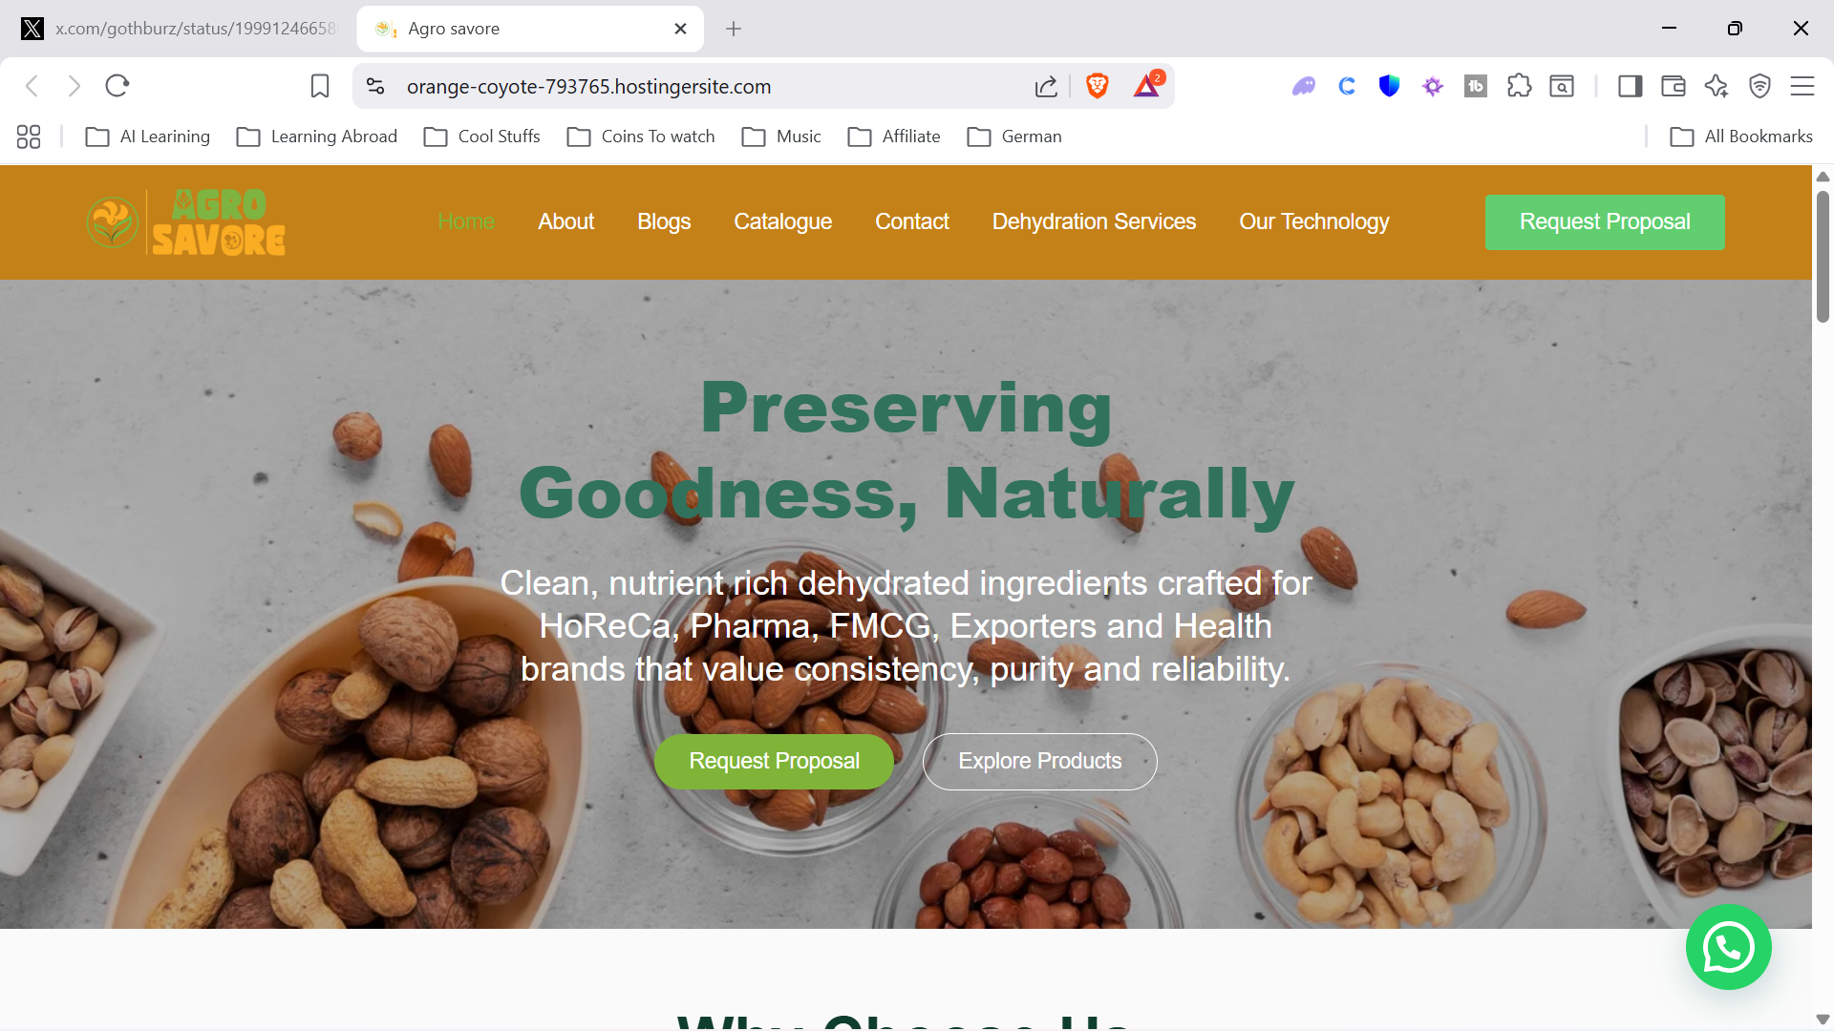

Correction 2 Mail integration for catalogue download ( ignore if it will work once integrated)
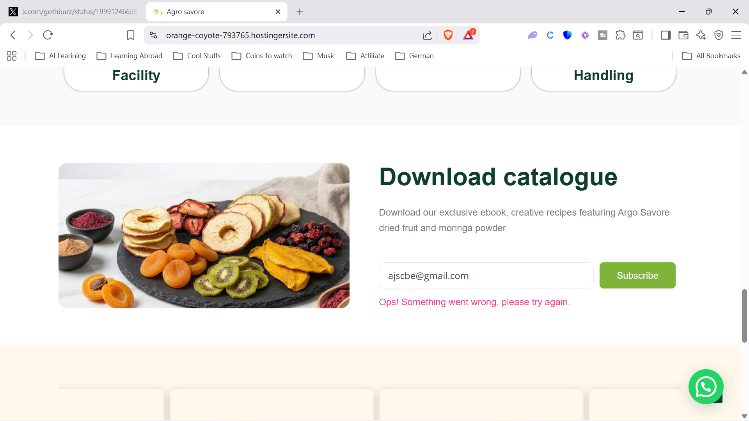

Correction 3 on clicking on Read More Button from Orange Peel, Curry Leave Powder, Mango Slices
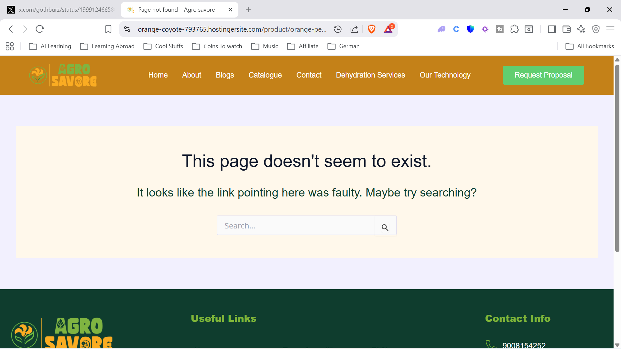

Correction 4 on clicking on Read More Button from Green Banana, it takes me to contact page
Expected It should open a page with Green Banana Benefits

Correction 5 Review the STARS are not visible properly after review submission (looks odd)
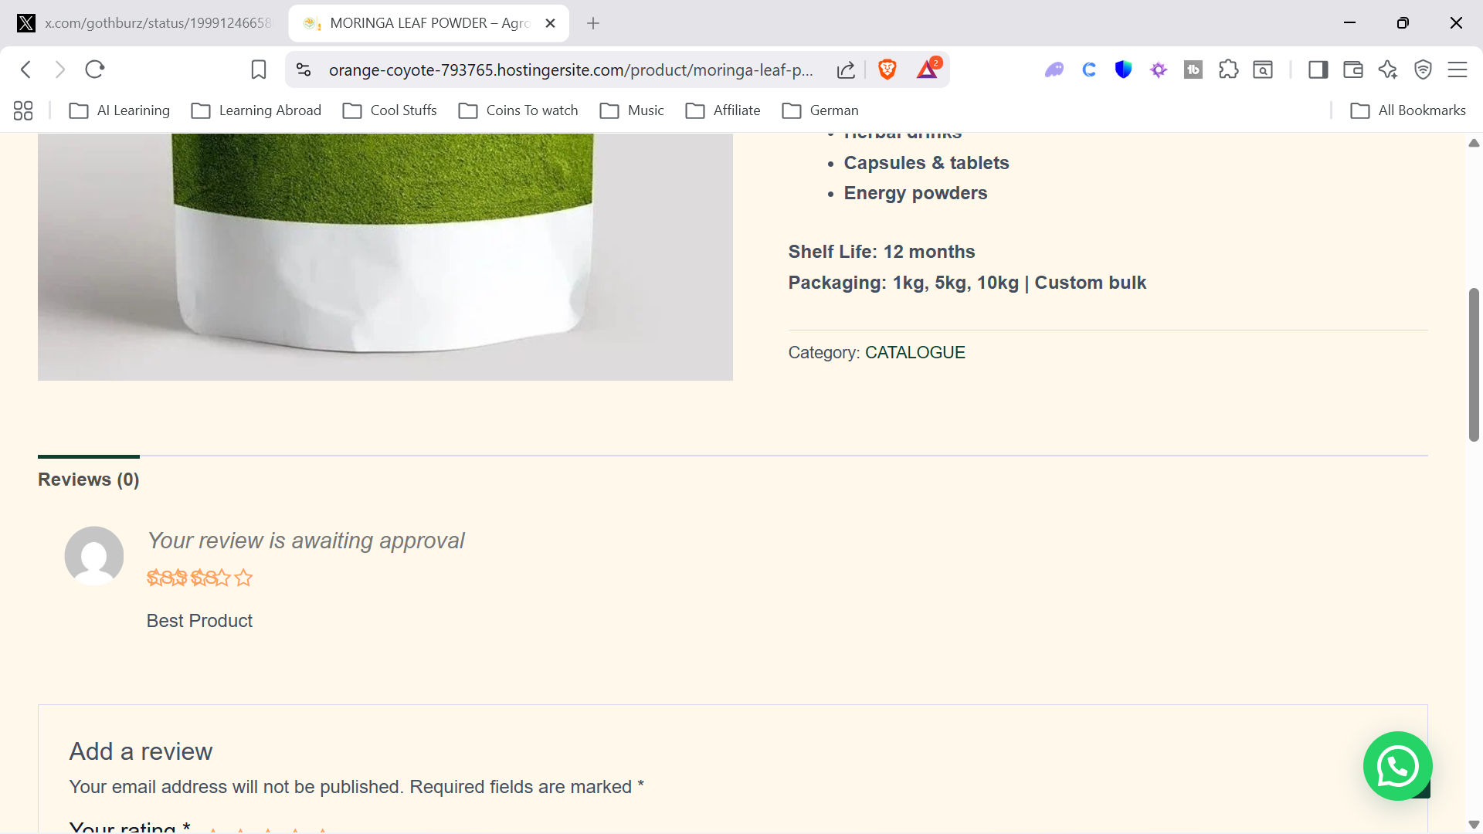

Correction 6 Contact us form throws same validation error for all fields (Explain how it is routed in real time)
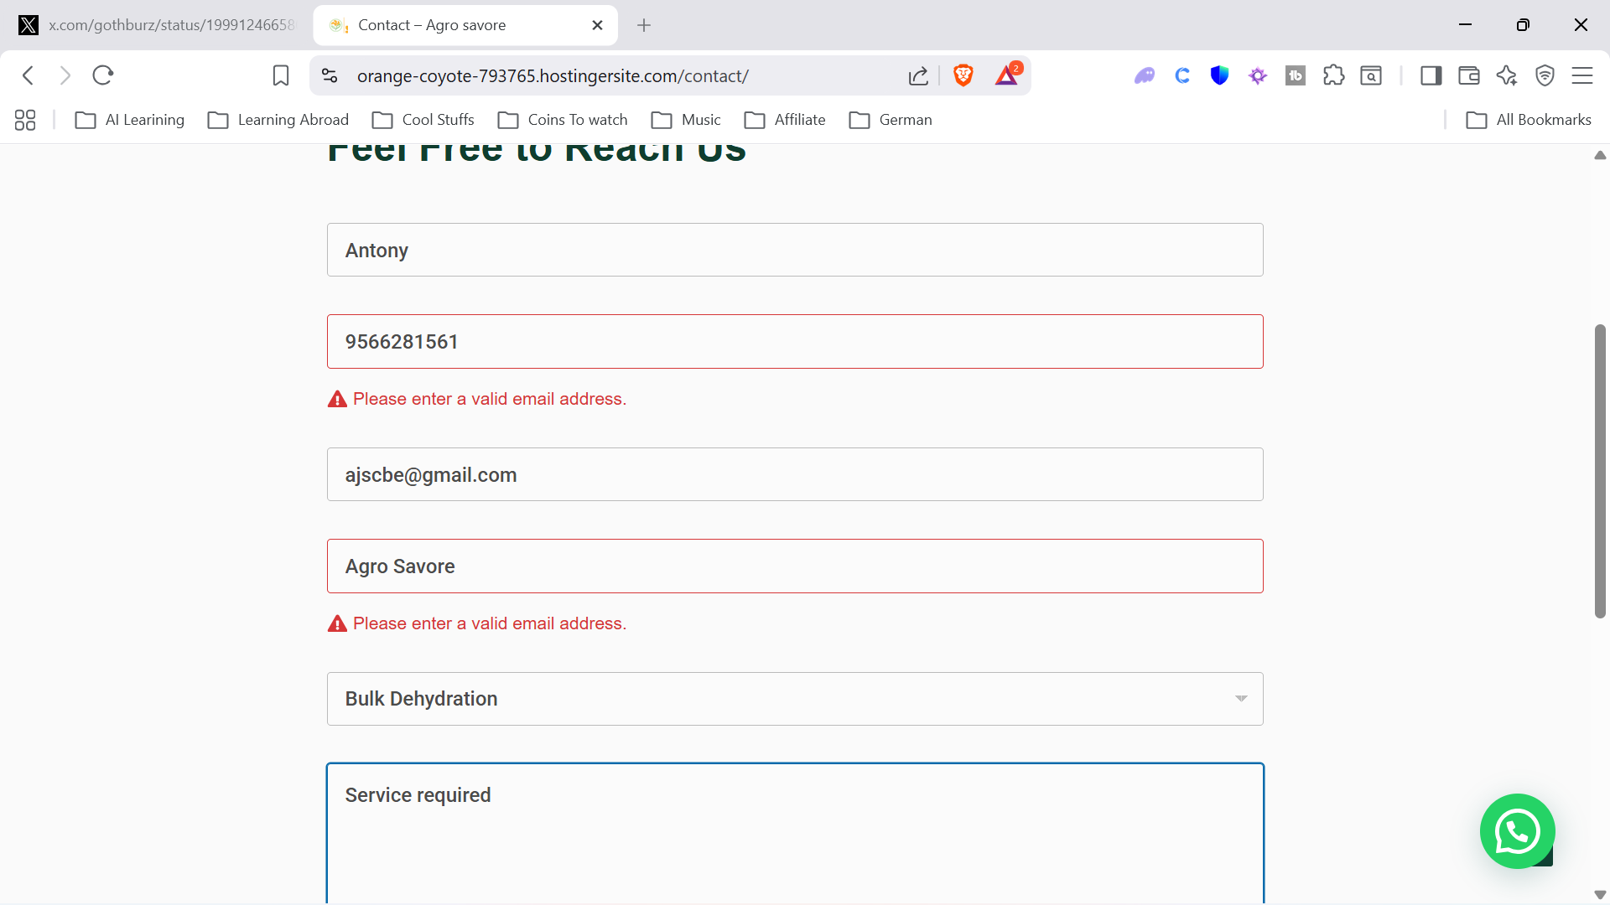
Correction 7 In mobile view and in the Why Choose US section the words are hidden in the carousel
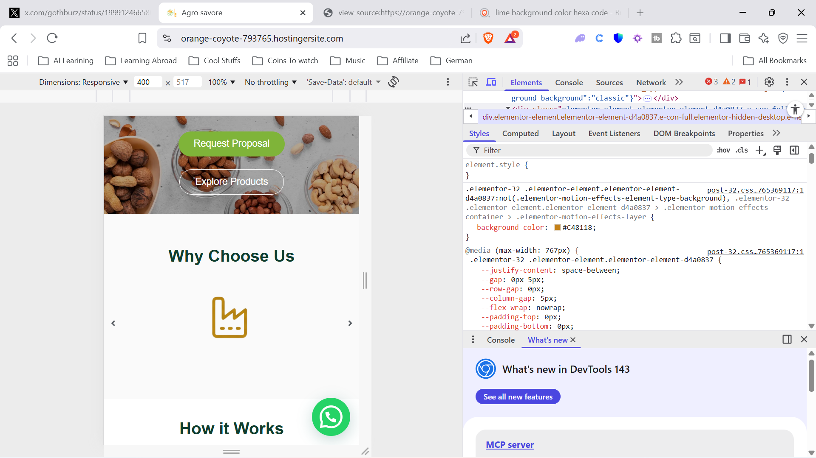

Correction 8 Maintain Consistent on the Font Style and Size across the site
Correction 9 Download Brochure functionality should be working once integrated

